Class Number Name

Machine number Experiment date Report date

**Experiment topic:**

Simple queries (2)

1. **Experiment objectives**

1）Master the use of GROUP BY and HAVING clauses.

2）Master the methods of modification of tables

**2. Experimental content**

4.1 Use of GROUP BY and HAVING statements

1) Get the average salary in each department (or by department)

NOTE: The attribute (dno) in the SELECT clause MUST agree with the GROUP

BY attribute (dno).

The HAVING clause can ONLY be used when a GROUP BY clause is present and is

used to choose between groups.

2) How many employees work on each project (using WORKS table)?

3) Get the departments having an average salary below £30,000.

Note: Only departments d2 and d3 are selected because their average salary is less than

£30,000.

HAVING clauses choose between groups and MUST conform to the syntax:

4) Get the projects having less than 9 employees working on them (i.e.

HAVING a COUNT of employees less than 9)

5) Get a unique list of department numbers (Use of DISTINCT predicate -

eliminates duplicate records from result)

6) How many employees are there in each department? (See query 1)

7) List the departments (by department number) that have a total salary of

more than £300,000. (see query 2)

8) How many employees earn £20,000 or £25,000?

4.2 INSERT, DELETE and UPDATE

1) Insert a new record with eno 'e51', ename 'mallon', age 32, salary 26000.00 ,

supno 'e17' and dno 'd2';

Note: Check the database to see if this record has been entered.

2) Delete the employee with an employee number of 'e51'.

Note: Check the database to see if this record has been deleted

3) Using similar SQL code, try to delete the employee with an employee

number of 'e19', you should find that an error is generated. Study the error

message and determine why the deletion operation is prevented. Ask a

demonstrator if you are unsure.

4) Change the budget of project number 'p13' to £650,000 (is £520,000 at

present).

Note: Check the database to see if this record has been changed

5) Change the employee named 'oliver' to 'pearson'.

6) Add a new record with the following values:

eno 'e60', ename 'young', age 51, salary 60000.00, supno 'e1',

dno 'd1'

7) Now delete this record using the SQL DELETE command

**3. Experiment procedure**

According to the task, list the task description, the screenshot of the solution process and the screenshot of the running result.

3.1 Task description

The task solution and results

4.1 1）

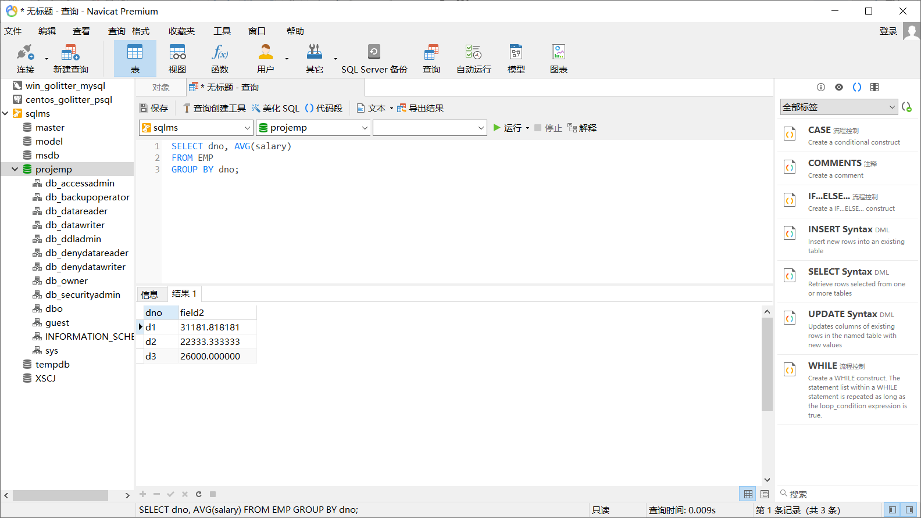

2）

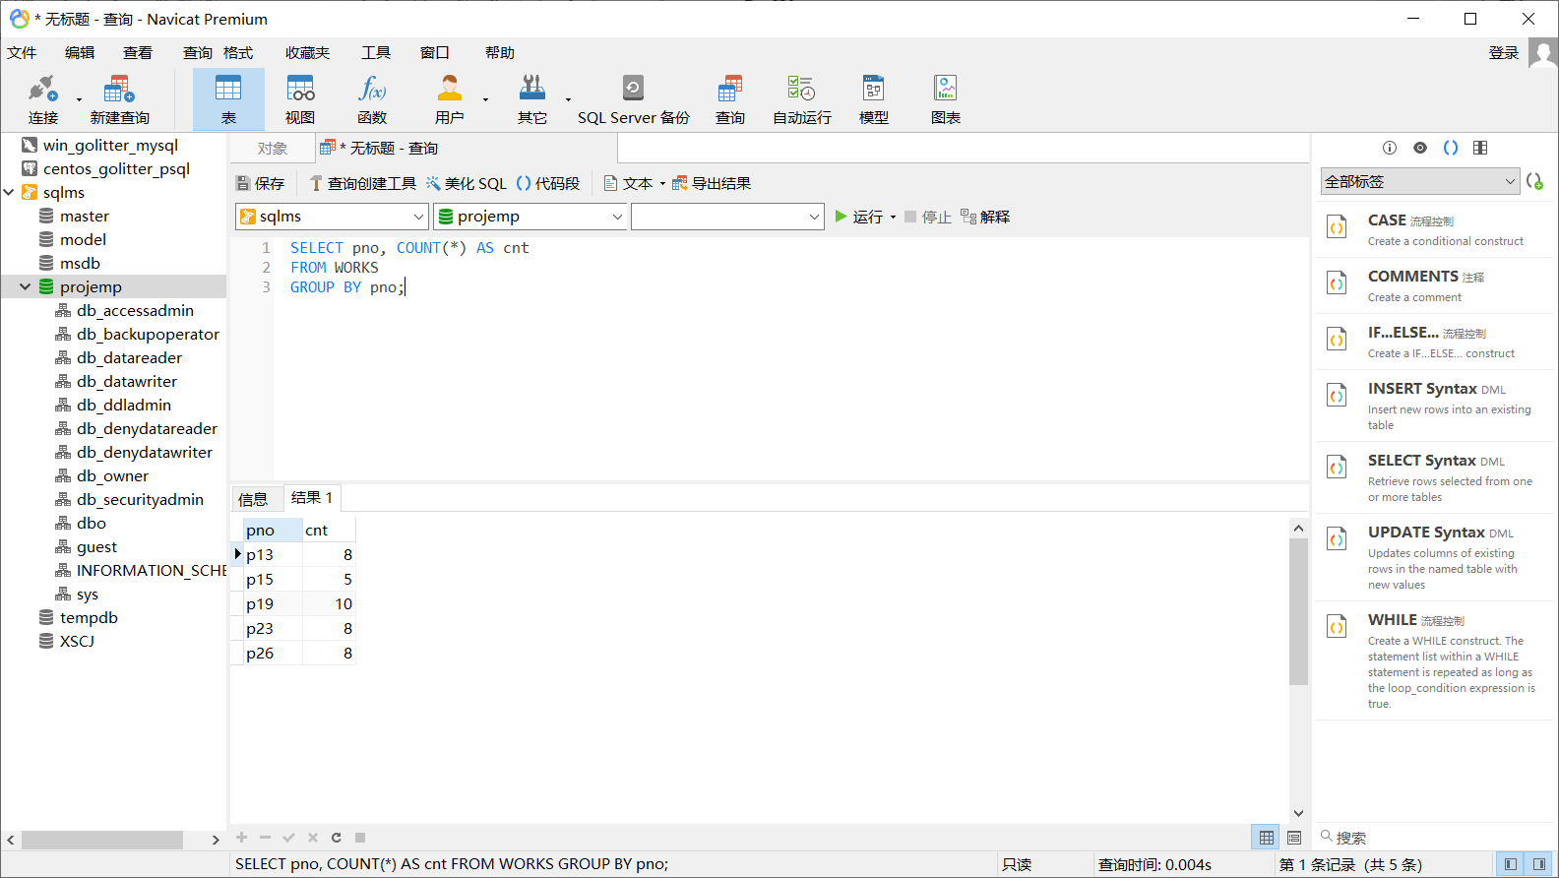

3）

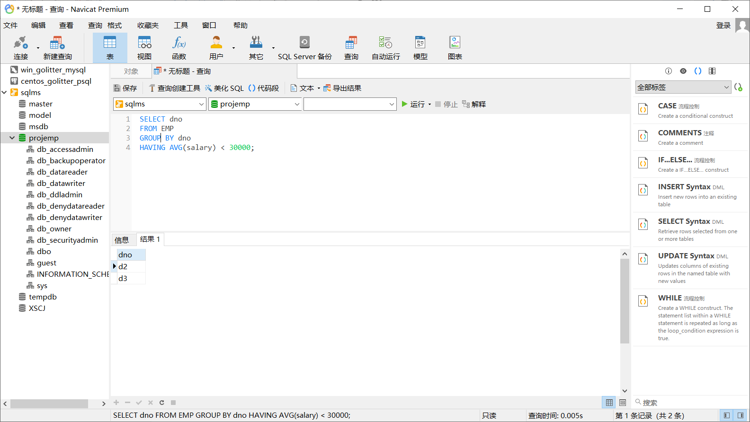

4）

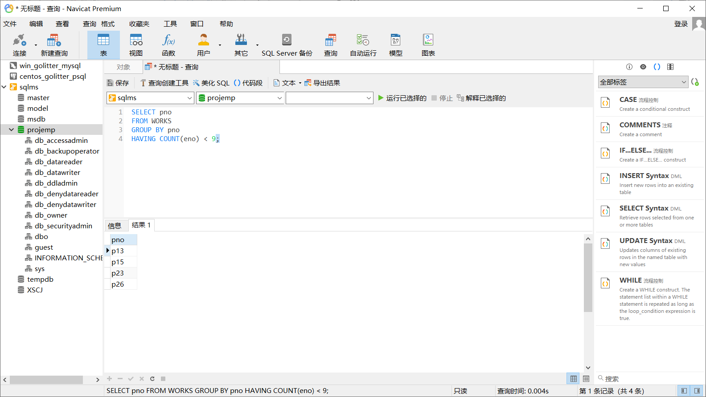

5）

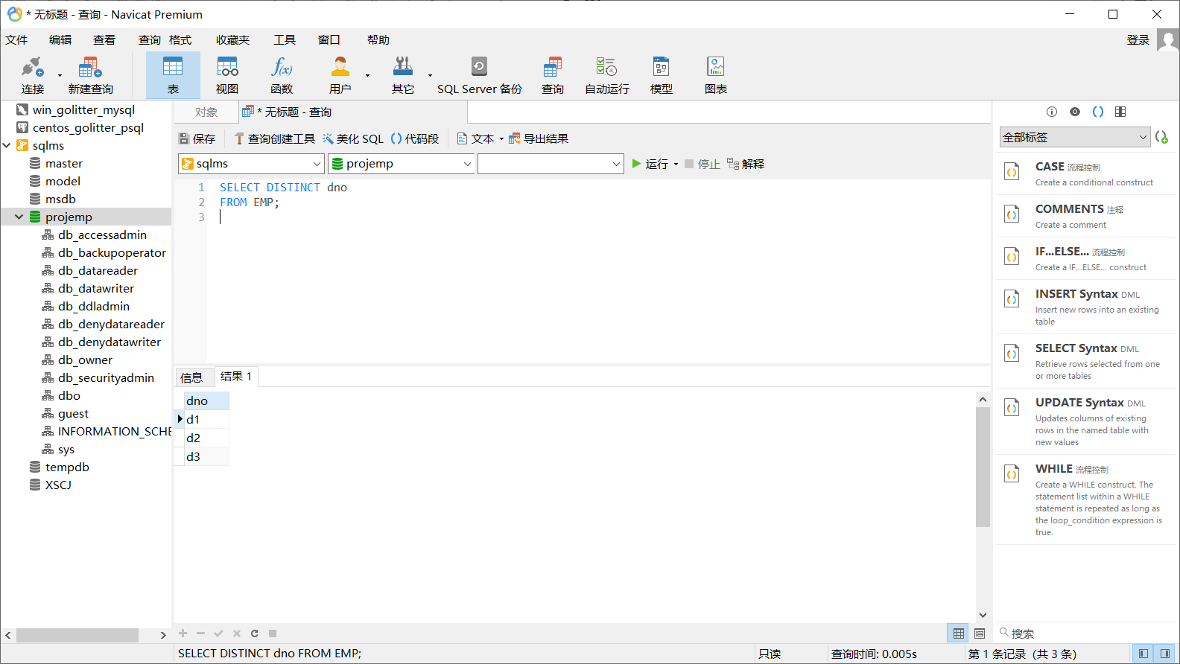

6）

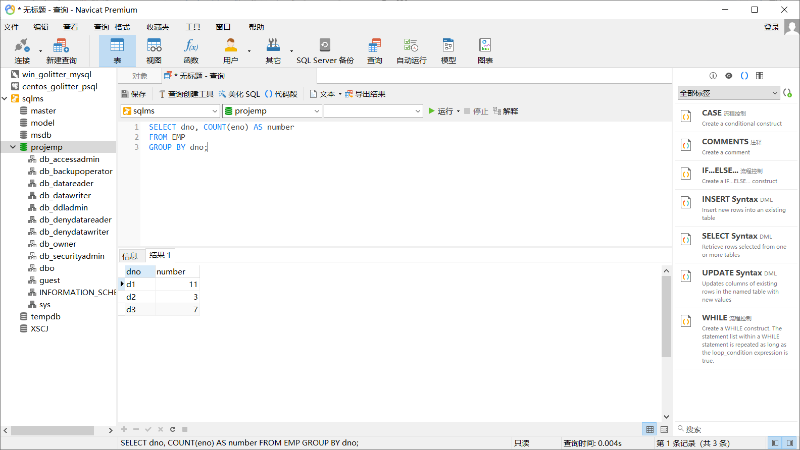

7）

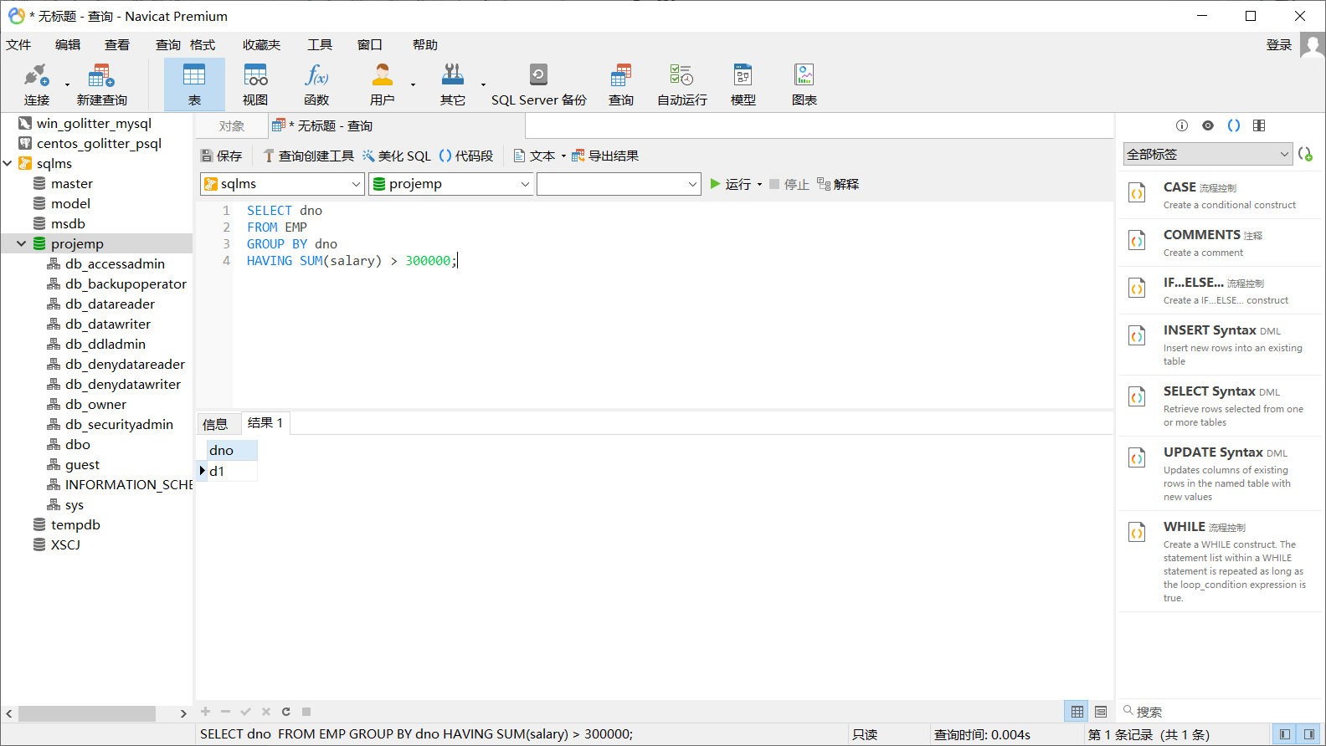

8）

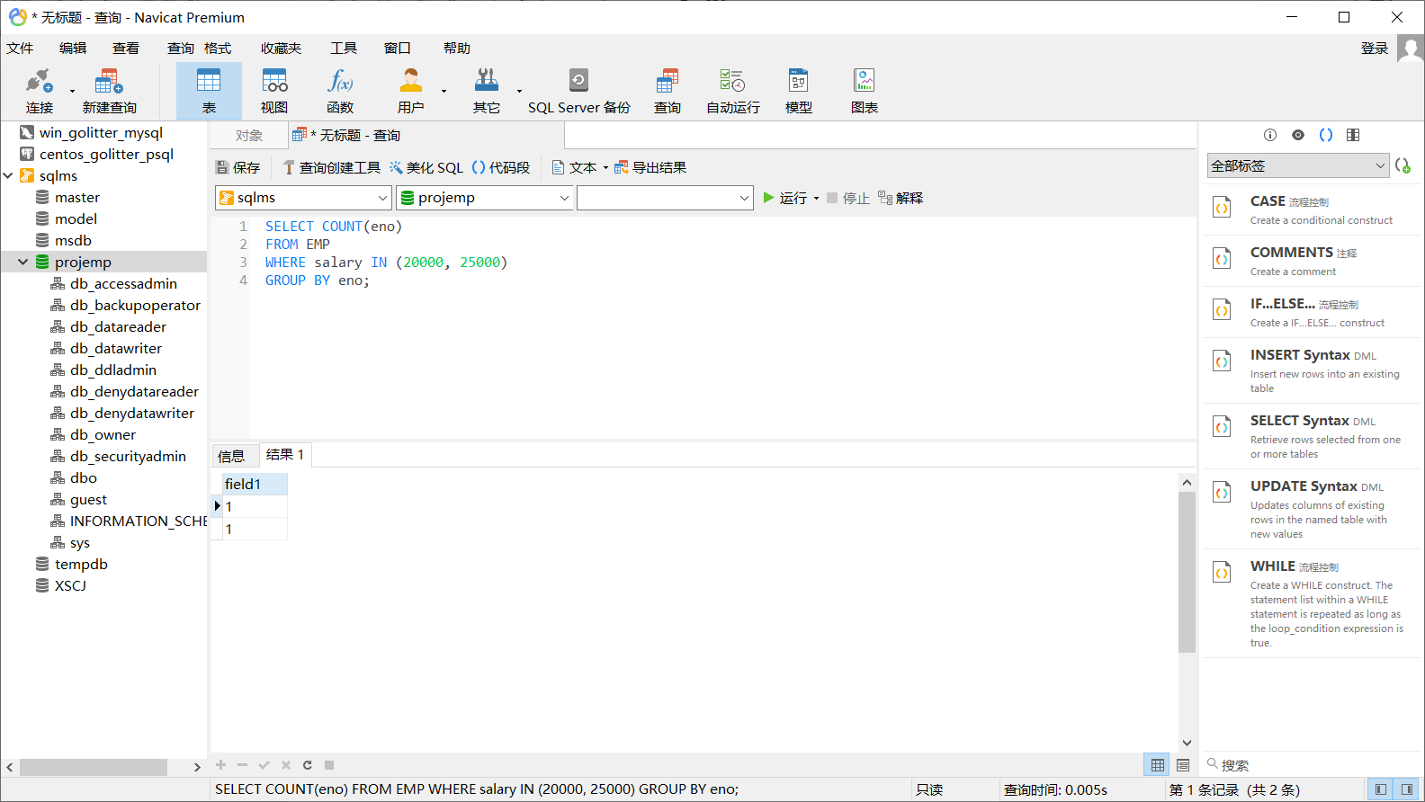

4.2 1）

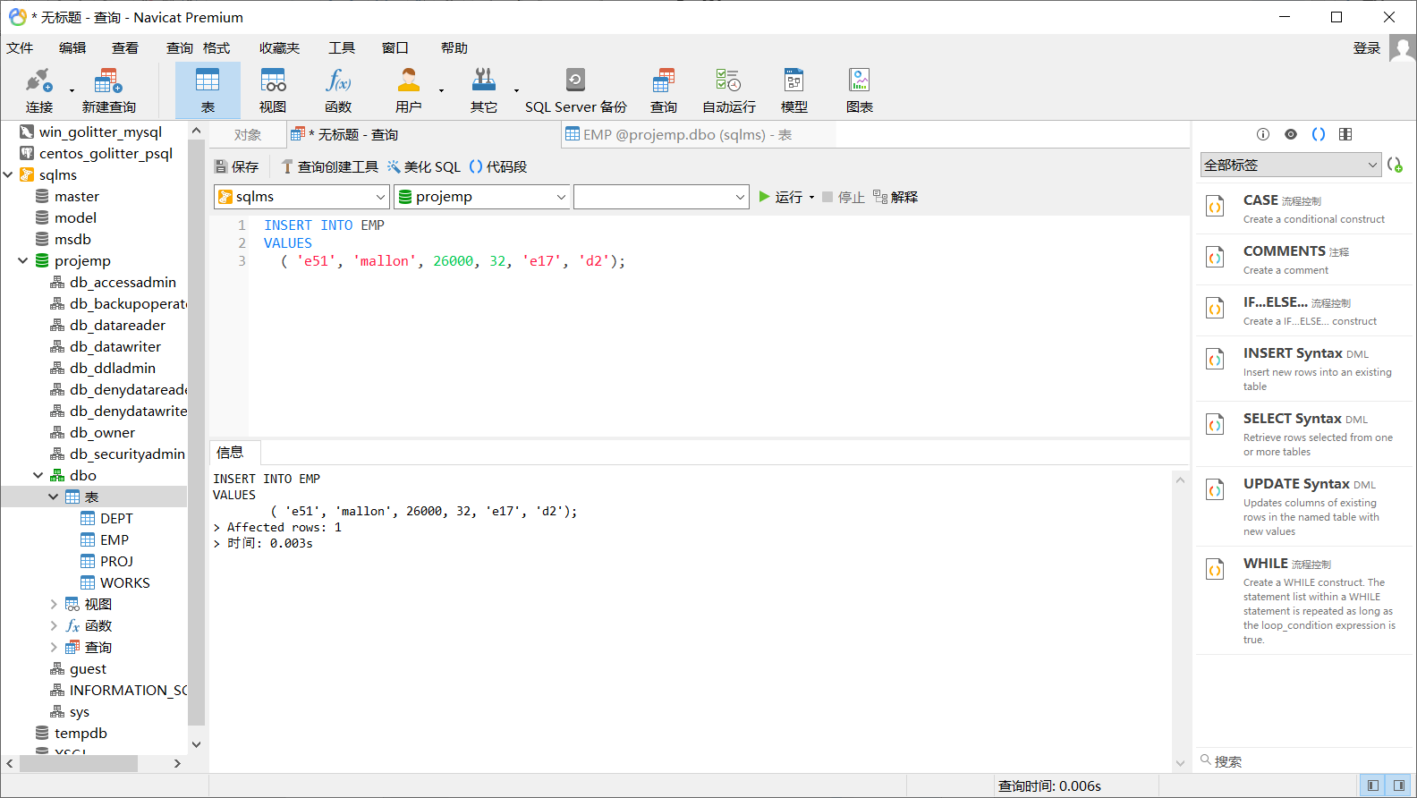

2）

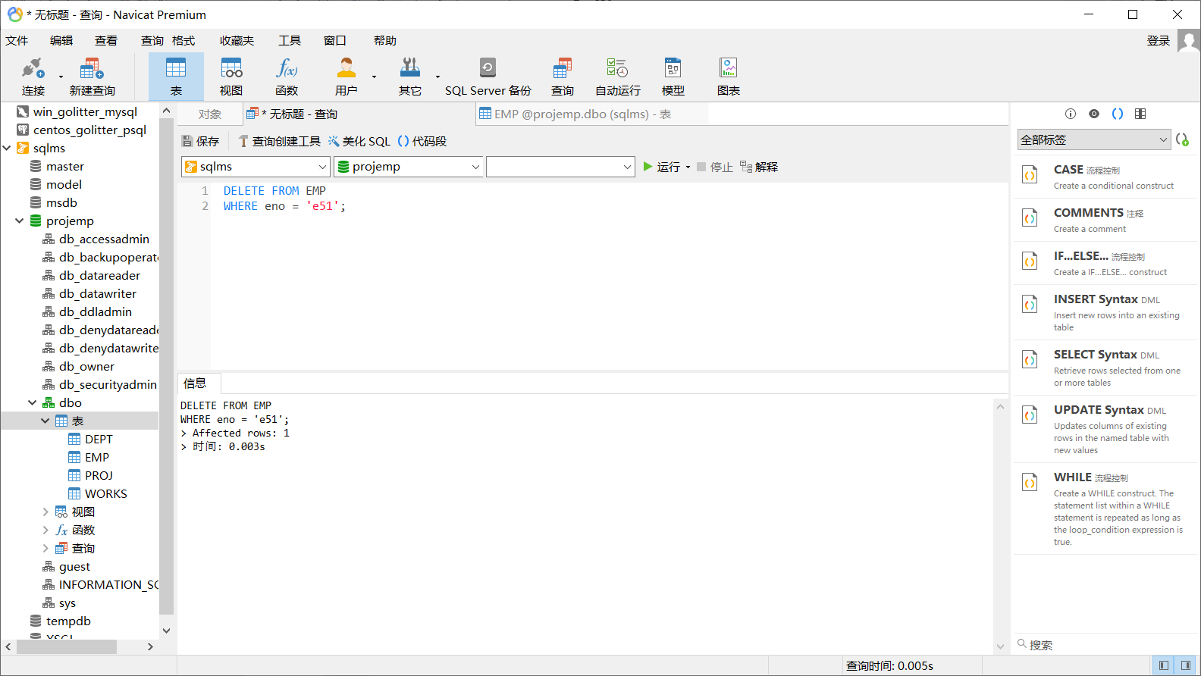

3）

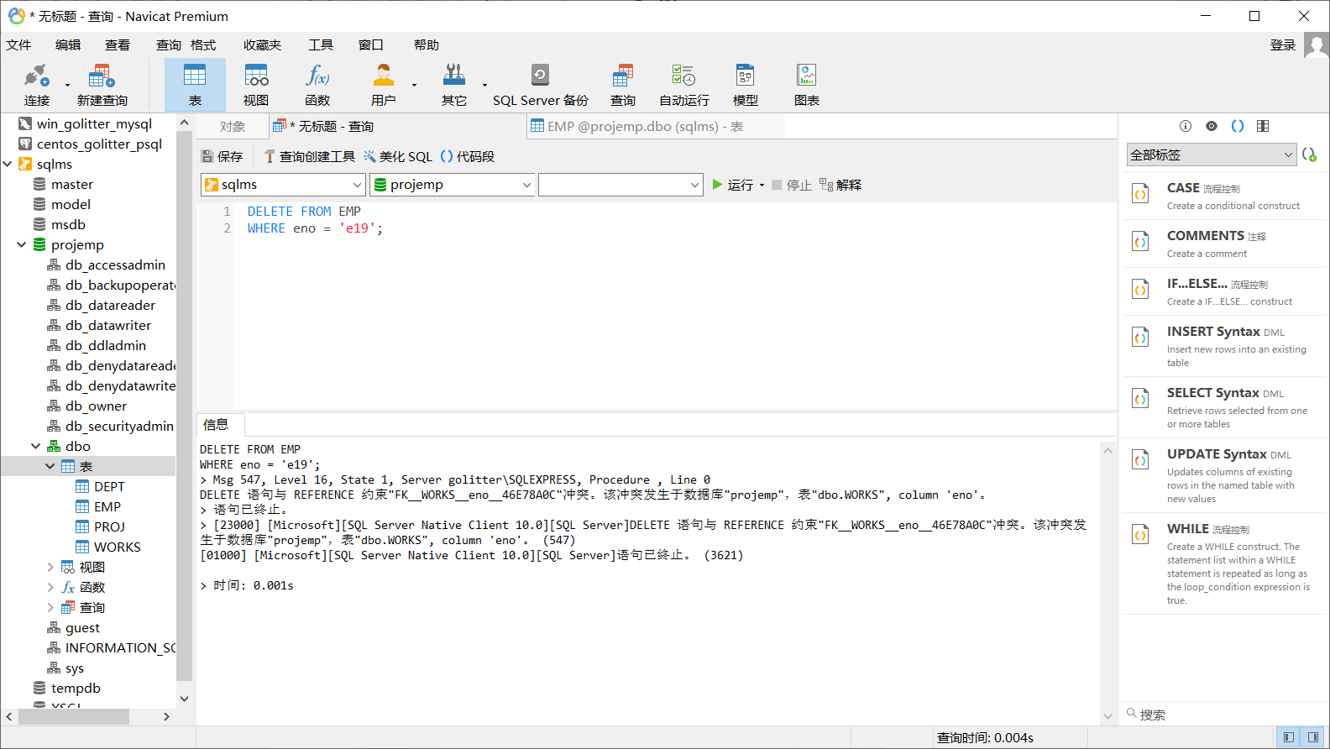

4）

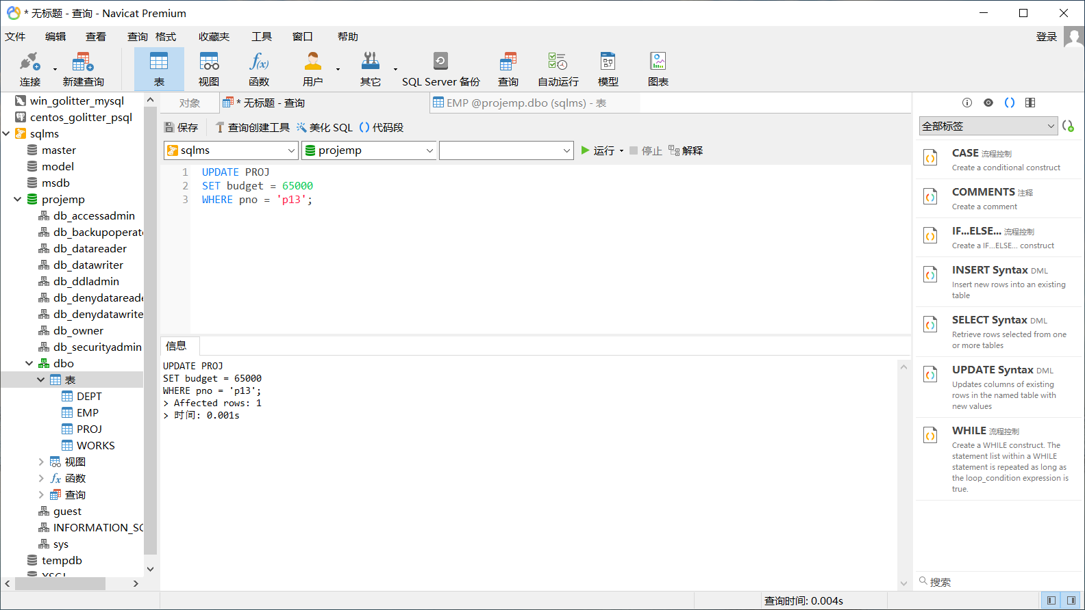

5）

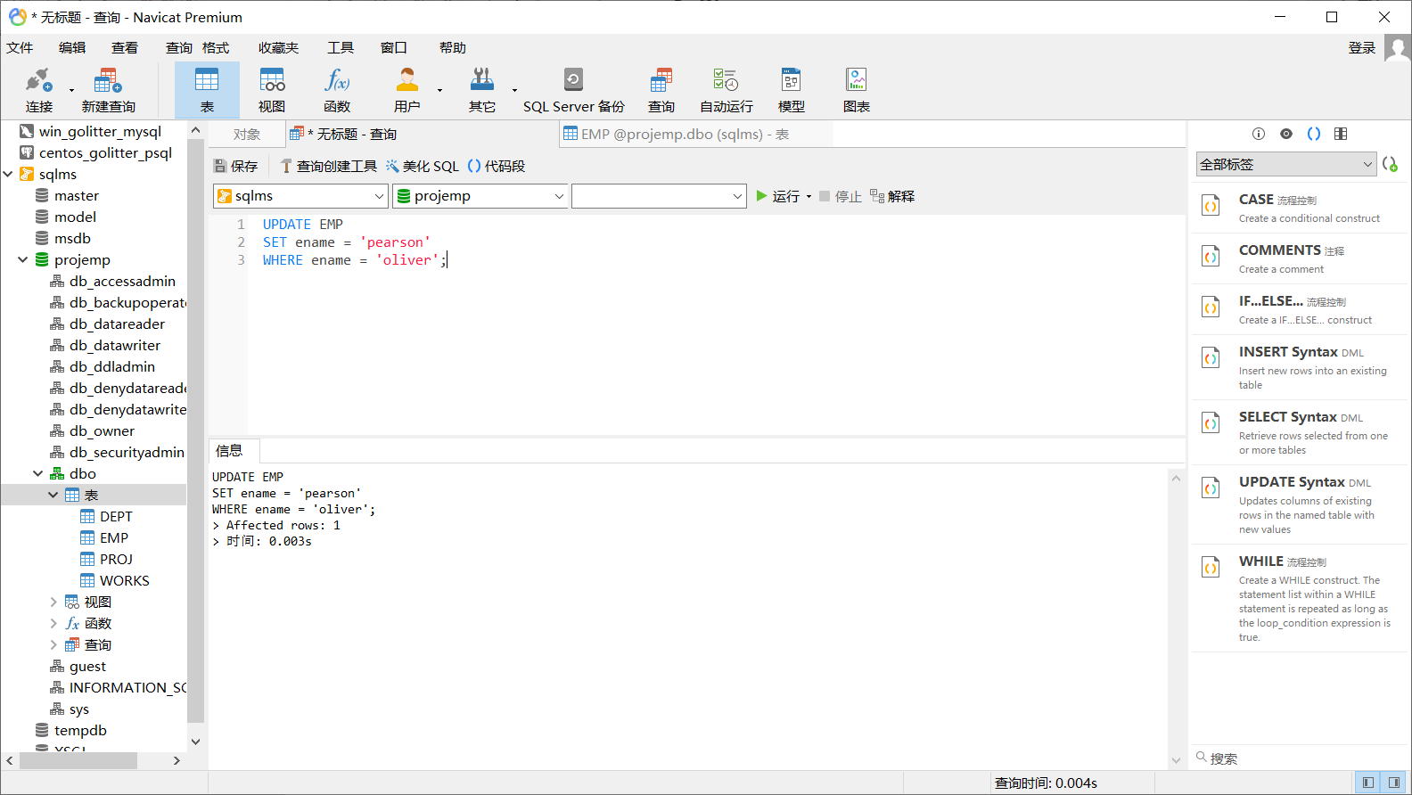

6）

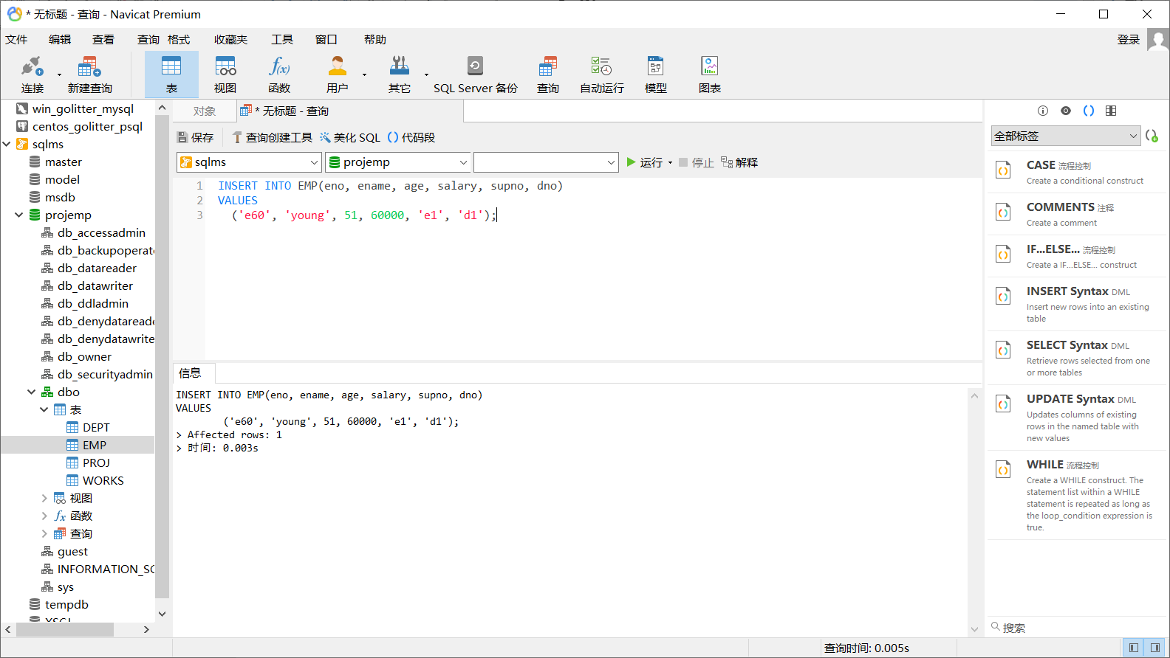

7）

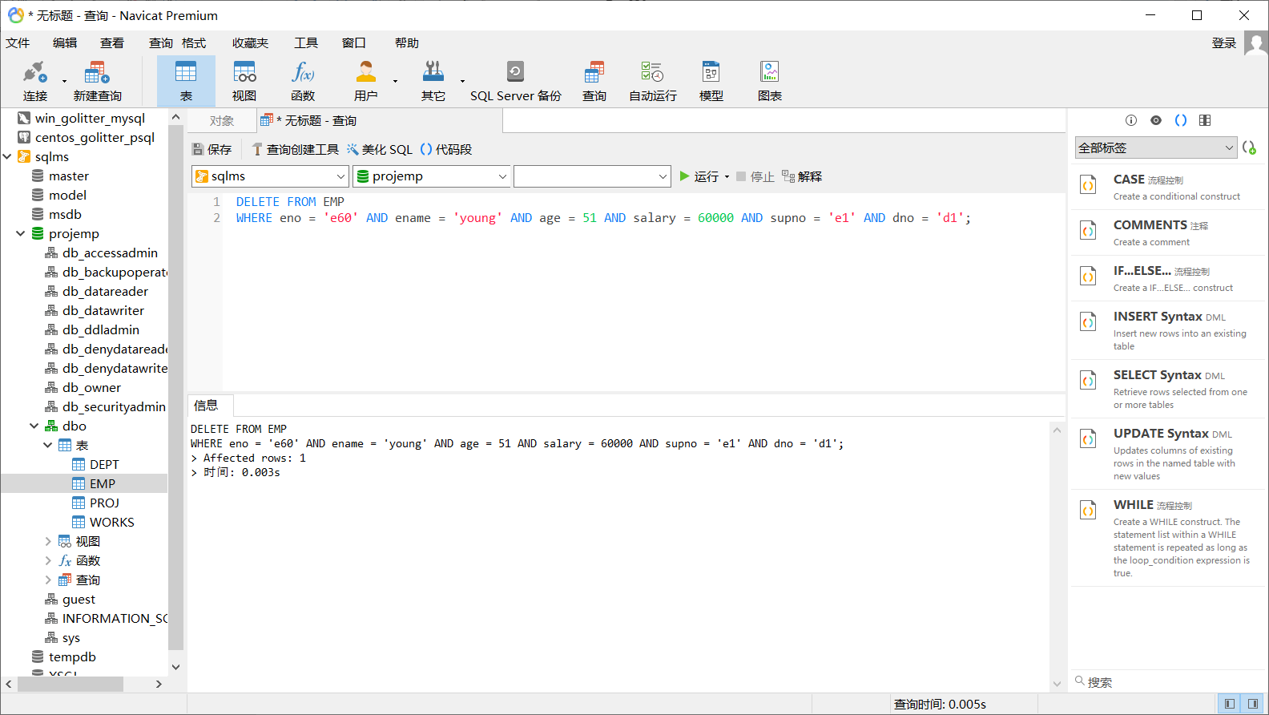

3.2 Debugging analysis

Problems during the debugging process and solutions

Give the program running screenshot

**5. Summary and experience**